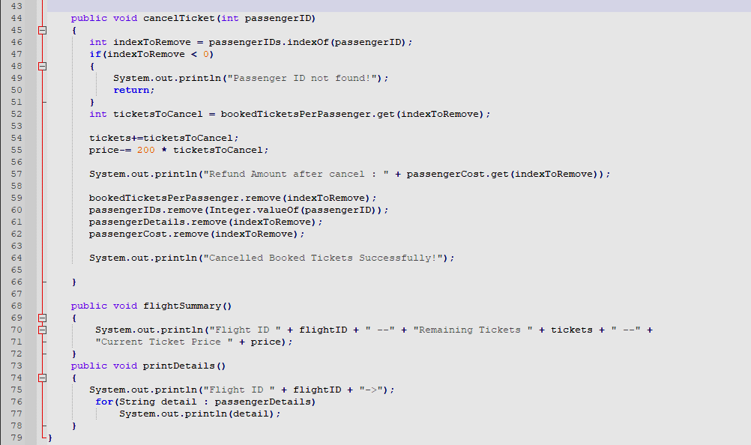
Explanation of my part in our group project.

44 : Create public method cancel tickets booked by a passenger ID
46 : Find the index to remove from all lists
54 : Increase number of available tickets
55 : Change price to new value after cancellation
57 : Calculate refund
59-62 : Remove details of passenger from all lists
64 : Print details about Cancelled Booked Tickets
68-72 : Functions to print details about flights
73-78 : Functions to print details about passengers

